Abstract— In our study, 8 healthy participants were instructed to perform a visual attention task before and after the tACS session. We found that the subjects receiving real stimulation show more reaction time shortening than the sham stimulation group. Further, the power of gamma oscillation after stimulation is also higher in the real stimulation group.
Transcranial Alternative Current Stimulation (tACS) Modulates Behavior and Brain Dynamics in Visual Attention Task
Tianyi Zheng¹⁺, Masato Sugino¹, Yasuhiko Jimbo¹, and Kiyoshi Kotani²

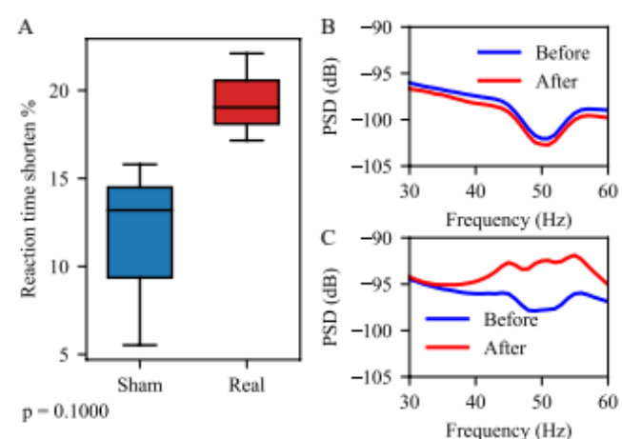
Clinical Relevance— This study shows the effect of tACS on brain activity, which results in the enhancement of visual attention. The findings of this study may help in designing better clinical trials to achieve neuroenhancement.

introduction
Transcranial alternative current stimulation (tACS) is found to have effects on the ability of visual attention [1]. According to the parameters and placement of stimulation, previous studies find tACS can improve, impair, or have a more subtle effect [2]. However, the effect of tACS on brain activity during visual attention tasks remains unclear. We tried to use EEG to monitor the activity change during the cognitive task before and after real/sham stimulation.

methods
Figure 2. Effect of tACS on behavior and brain dynamics. (A) Reaction time shortening. (B) Power spectral density (PSD) of gamma oscillations before and after sham stiulation. (C) PSD before and after real stimulation.
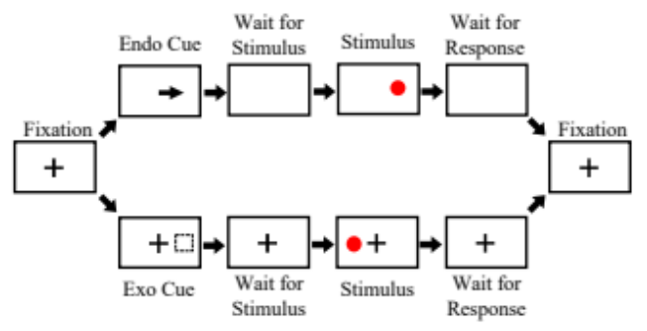
Eight subjects were divided into two groups, and acknowledged the probability of receiving real or sham tACS was fifty-fifty. The parameter for real stimulation is 40Hz, 1.5mA peak-to-peak, 10 min, position Cz and P6. Subjects were instructed to perform a modified version of the Posner Cuing Task [3] both before and after the tACS session. Fig. 1 shows the detail of the task. Two kinds of cue will be presented after fixation: endogenous (endo) cue, which is an or exogenous (exo) cue, which is a flashing box. After an interval to wait for the stimulus, a stimulus will pop up, which is 80% to be the same position as the cue and 20% to be the opposite position. Subjects were asked to click a button as soon as possible when they saw the stimulus. During the task, we use 32 channel EEG device to monitor the brain dynamics (g.USBAMP, g.tec medical engineering GmbH). All human experiments were approved by the Research Ethics Committee of The University of Tokyo (21-271).
Figure 1. Visual attention task

RESULTS & DISCUSSION
Three of four subjects, for both real and sham stimulation group achieve shorter reaction time after tACS session. Fig. 2A shows the percentage of reaction time shortening that the group receive real stimulation shows more reaction time shortening than the group receive sham stimulation. Fig. 2B and 2C show the change of gamma oscillation (here is the segment of 30-60Hz) before and after the tACS session. For sham stimulation as Fig. 2B, the power of gamma oscillations shows very little changes. However, for real stimulation case as Fig. 2C, the power of gamma oscillations shows increasing after the stimulation. Those findings suggest that the gamma-band tACS can entrain gamma oscillation which may result to enhancement of visual attention ability.
References
- Reteig, L.C., Talsma, L.J., van Schouwenburg, M.R. et al. Transcranial Electrical Stimulation as a Tool to Enhance Attention. J Cogn Enhanc 1, 10–25 (2017).
- Joseph B. Hopfinger, Jonathan Parsons & Flavio Fröhlich (2017) Differential effects of 10-Hz and 40-Hz transcranial alternating current stimulation (tACS) on endogenous versus exogenous attention, Cogn Neuroscience, 8:2, 102-111
- Posner, M. I. (1980). "Orienting of attention". Q J Exp Psychol. 32 (1): 3–25.

 * This research is supported by JSPS KAKENHI (22K19785), Asahi Glass Foundation and Tateisi Foundation to K. Kotani, and JSPS DC1 fellowship (22J22909) to T. Zheng. ¹ Graduate School of Engineering, The University of Tokyo ² Graduate School of Frontier Sciences, The University of Tokyo ⁺ Email of corresponding author: zheng@neuron.t.u-tokyo.ac.jp

